 information sheet
For internal use only

Activating QRESEARCH Uploads

General information
- Activating the upload does not start transferring data to EMIS – it merely queues up data ready for EMIS to collect. The whole process of activation takes only a few moments and can be done at any time.
- EMIS will collect the data from this queue at a pre-agreed time. At present, data collection will take place only outside surgery hours so that system speed is not affected.
- Deactivation deletes the contents of the queue completely, rather than pause transmissions. It should only be used if you wish to no longer participate in the QRESEARCH study.
- To ensure that play patients are not transferred inadvertently, it is suggested that you 'opt them out' of the study manually. For information on how to do this, please see page 4.
If you have any questions or problems at any time during this process, please contact
Network Support Team (0845 122 2333) and choose option 25 on the automated system.

Activating the upload
- Check if your system is up to date.
To do this, please choose option CS then SF from the main EMIS menu. You should see a menu similar to the following:
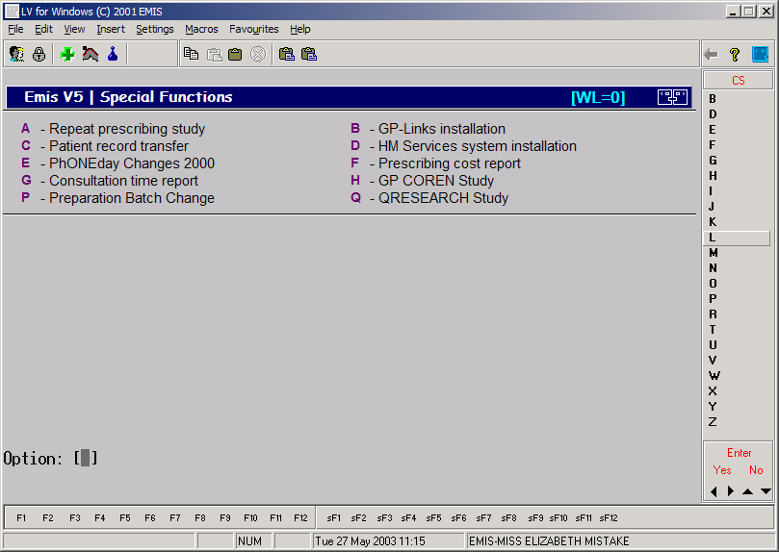

If the ‘QRESEARCH – Project’ option is not available, you will need to contact Project Support at EMIS before you can continue.

- Press ‘Q’. You should now be prompted for a password:
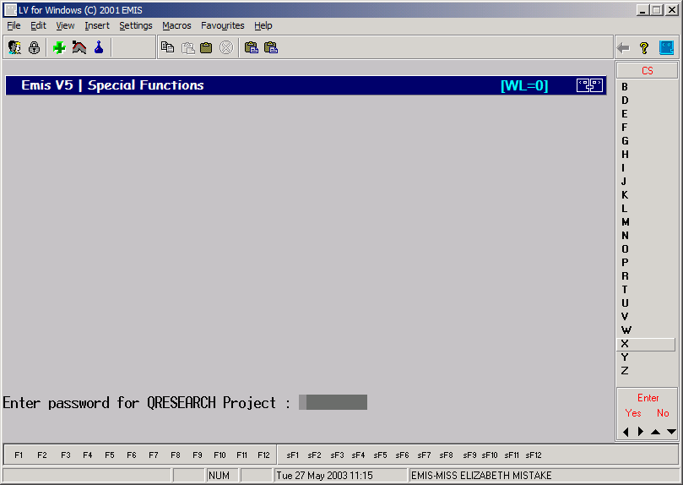
At this stage, enter ‘QRESEARCH’ in upper case and press the ‘enter’ key.
- You should now see a screen similar to that below:
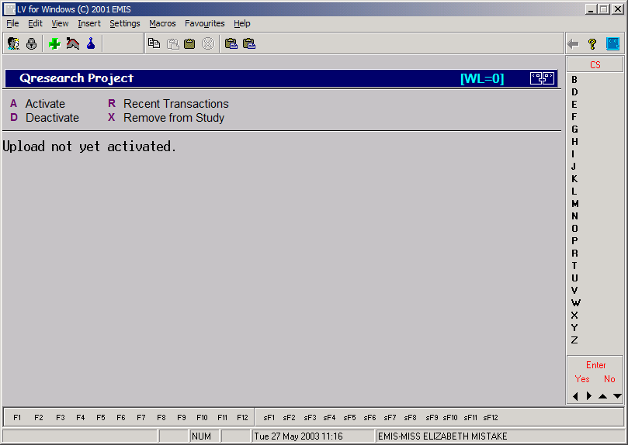
To activate the upload, press the ‘A’ key.
- A message will now appear stating that activation will take place in the background:
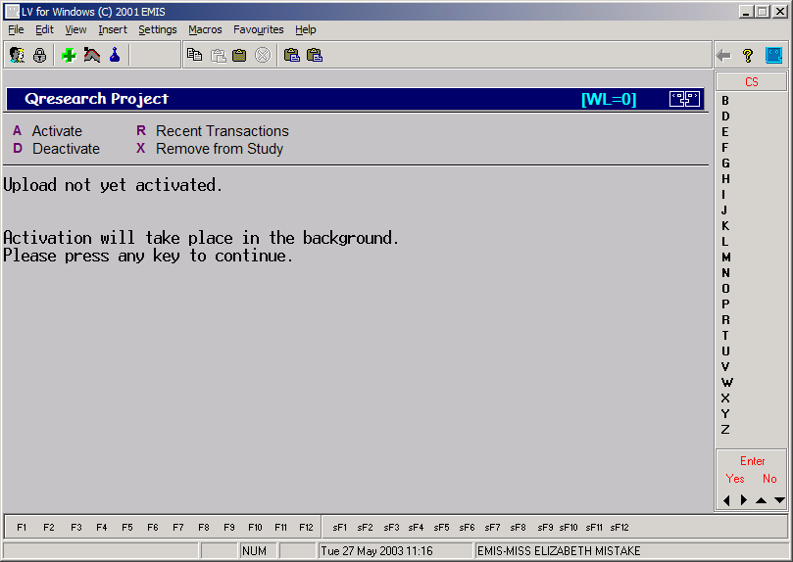
- After a few seconds, the ‘Upload not yet activated’ message will be replaced by a message similar to ‘Activating: 34/10000’, denoting that 34 patients from the practice population have been queued for transfer. At this point, you can press ‘F1’ to return to the Special Functions menu. You can return to the QRESEARCH menu at any time to check the status of activation.
Once activated, you can deactivate the upload at any time you choose. To deactivate the upload, please choose the ‘D’ option from the QResearch Project menu. You should only do this if you no longer wish to participate in the study.

Viewing recent transmissions
If you wish to view what data has been transmitted to the QRESEARCH database in the last 24 hours, you can use the R-Recent Transactions option. This provides a listing of all patients transmitted during the last 24 hours, and whether a full record or partial record was transmitted.

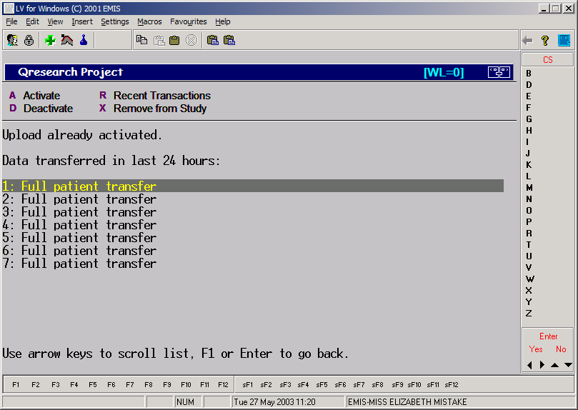
If a patient has been removed from the study, it will be noted in this log.

Removing patients from the study
To remove a patient from the study, choose X-Remove from Study from the main QRESEARCH menu. You will be prompted to search for a patient.
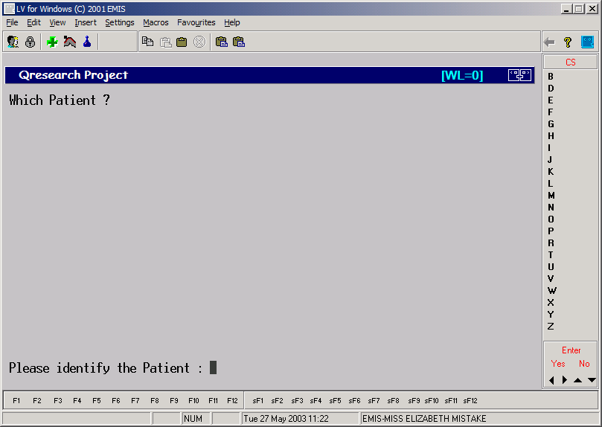
Search for the patient as normal. You will be asked to confirm if the patient should really be removed:
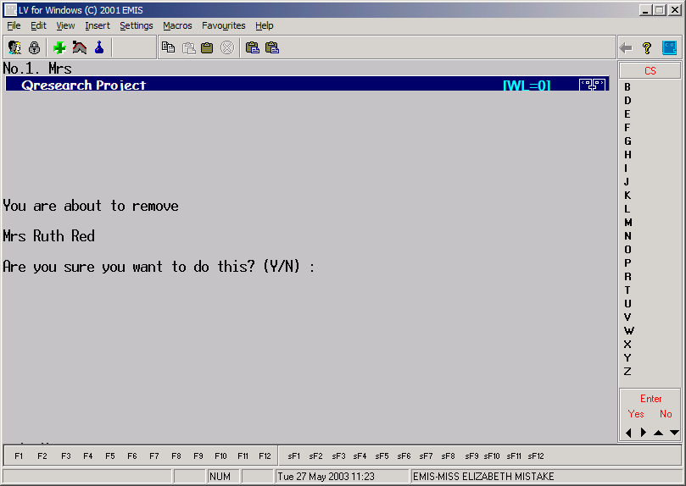
Once a patient has been marked as removed, all data will be deleted from the QRESEARCH database and no further uploads for the patient will occur.
Associated documentation
None

